Case 4-Eur-Greece-Mycenae-Mask of Agamemnon 2

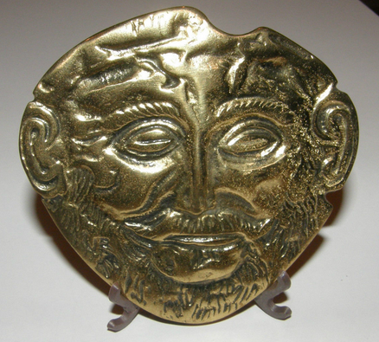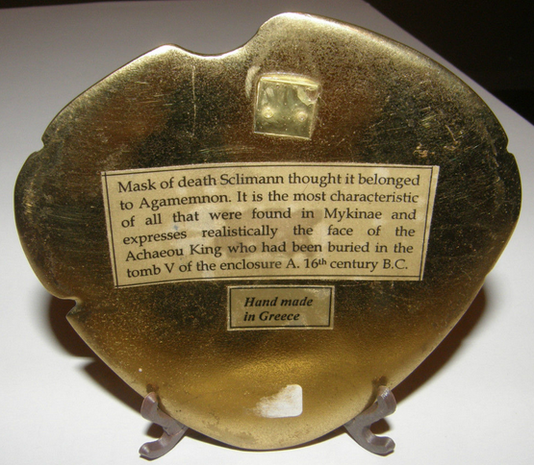 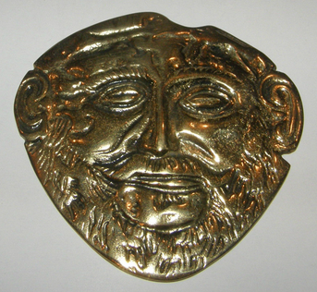

**“Mask of Agamemnon”,** replica in brass.

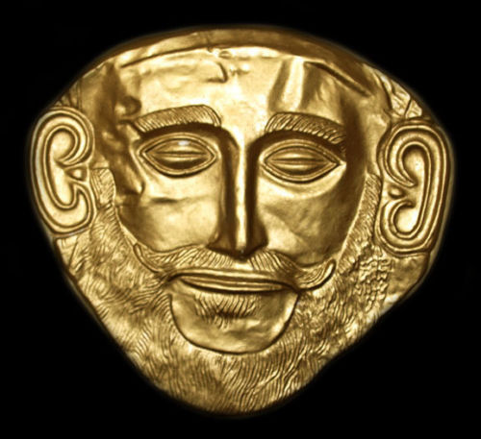

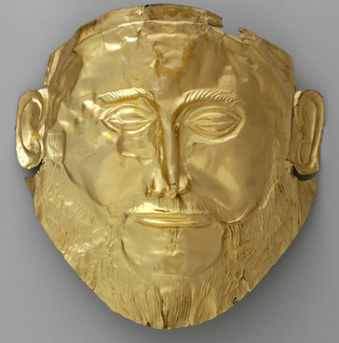­­­ 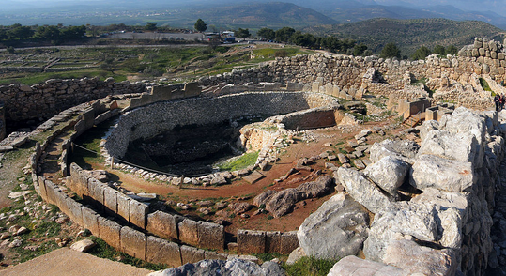

**Left: “**Mask of Agamemnon”, Alison Frantz Photographic Collection, American School of Classical Studies at Athens original in gold. Right: Grave Circle A, Mycenae, Greece, 1600-1500 BCE, stone wall enclosure, ca 1300 BCE. After https://www.google.com/maps/uv?hl=en&pb=!1s0x14a00266cdcd88f9%3A0x2c902cae



**Gold Mask of “Agamemnon,” Mycenae, Greece, 1550–1500 BCE.**

**This mask is dated to three hundred years earlier than Agamemnon’s life,**

**1250-1200 BCE. It falls within the early part of the Late Helladic period (1650–1050 BC), the time when Mycenaean Greece flourished in military exploits and architectural wonders like the “Lion Gate” and the “Tholos Tomb”. This mask is one of five discovered in the Late Helladic Period in 1876 by Heinrich Schliemann.**

**Geographical Area:** Mycenae

**Cultural Affiliation:** Mycenaean Late Helladic

**Medium:** original gold leaf, replica, brass.

**Dimensions:** replica, H 3 5/8 in tall, W 3 7/8 in

**Weight:**

**Provenance: original mask** discovered at Mycenae in 1876 by Heinrich Schliemann, now on display at the National Archaeological Museum in Athens (NM 624).

**Condition:** Museum specimen replica

**Discussion:** This mask is one of five discovered in the Late Helladic Period Grave Circle A at Mycenae ca 1500 BCE (Geldard 2000: 157), which was begun in before it was later enclosed in the acropolis during the 13th century BCE when the acropolis fortifications were extended (Gates 2000: 133). It included seven shaft graves of nine females, eight males, and two juveniles. Grave goods included engraved and inlaid swords and daggers and this gold mask, suggesting that warrior chieftains and their families were buried here.

This “Mask of Agamemnon” was identified by Heinrich Schliemann as the death mask of the legendary Greek king Agamemnon of Homer's *Iliad*. Without secure dating of the site in which the mask was found, Schliemann assumed this mask was evidence that the Trojan War was a documented, historical artifact of Homeric legend.

In the legend, Paris (the son of King Priam and Queen Hecuba of Troy) kidnapped Helen, the wife of Menelaus in Mycenae, and absconded with her to his home in Troy, a small fortress near the southwest mouth of the strait of Dardanelles in Anatolia (near modern Hissarlik in Turkey). Agamemnon, the king of Mycenae, took this as an affront to his polis and commanded his united Mycenaean forces to return Helen. The Greeks pursued the Trojans to their city, thus beginning the Trojan War, ca 1250 BCE. When Agamemnon returned to Mycenae from Troy, Aegisthus, the paramour of Agamemnon’s wife Clytemnestra, ambushed and murdered him and his cohort (Homer, *Odyssey* 11.409–11; Aeschylus 1986, p. x).

**References:**

Aeschylus. 1986. *Choephori*; “Introduction” by A. F. Garvie, Oxford U. P.

Gates, Charles. 2003. *Ancient Cities: The Archaeology of Urban Life in the Ancient Near East and Egypt, Greece, and Rome*. New York: Routledge.  
Geldard, Richard G. 2000. *The Traveler's Key to Ancient Greece: A Guide to Sacred Places*. New York: Quest Books.